Dear Valued Partner,
We appreciate your support as one of our trusted VoIP Managed Service Providers. To show our appreciation, we wanted to provide you with useful tools to help market to new customers and share your available VoIP service offerings. Below are a few sample social media posts with copy included, to give you a kick-start! Feel free to re-use these samples and add your own copy. Don’t forget to include [your business name] in each post and popular hashtags, try the ones at the end of this document!
Interested in co-branding or additional marketing tools? Please contact marketing@loopcommunications.com or call 704-754-5605

Sample Social Media Posts
[your business name here] offers a phone service with Loop Communications, so now you can send MMS text messages (audio, video and larger files) from your business phone number to an email address, staying in touch with your customers. Take advantage of this convenient and flexible feature. Read more here!
https://www.loopcommunications.com/loops-new-feature-mms/
{insert your business contact info here}
[your business name here] has partnered with Loop Communications for guidance and support in voice technology. If you want to activate any features or need assistance working remotely, please contact their support team for any questions!
https://bit.ly/301jdbm or call 800-586-0321
{insert your business contact info here}
[your business name here] is a proud partner of Loop Communications. Keep your distance but stay connected with the Conference Bridge feature! If you are working from home or sitting in your car, you can meet up with your team or valued customers from anywhere. Don’t miss out on business, stay flexible and convenient with this feature! Learn more:
https://bit.ly/3cvyfcN

{insert your business contact info here}
Wherever you need to work, Loop Communications can assist! [your business name here] has partnered with this voice provider to offer the most valued features. SMS text to email
https://bit.ly/2JiITGC Increases your ability to reach anyone, anytime, anywhere. Simply send a text from your business phone number straight to anyone’s email address, how easy!

{insert your business contact info here}
Take your business home with these top features from Loop Communications, a partner of [your business name here]. Support your operations with flexibility and reliability, learn more here! https://bit.ly/2YZI0Mh

{insert your business contact info here}
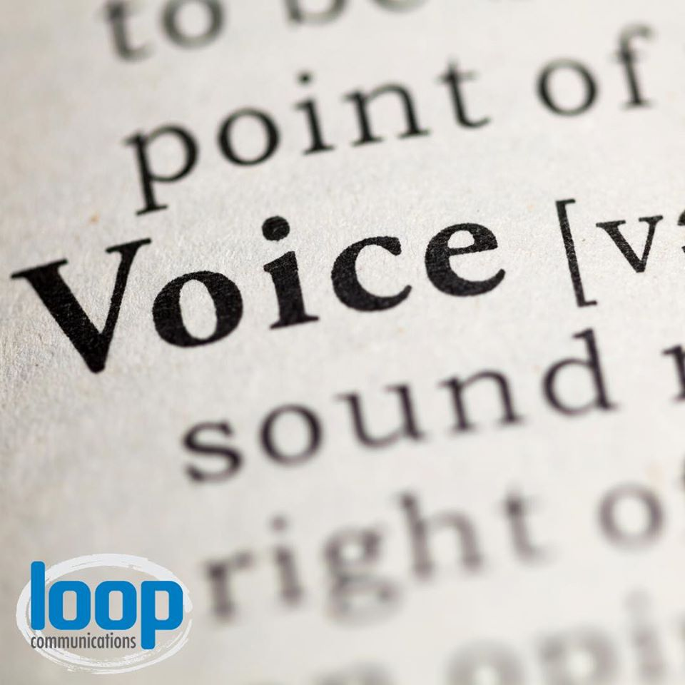 | VoIP technology enables traditional telephone services to operate over computer networks. Switching to VoIP with Loop Communications, a partner of [your business name here], will help you save money, support multitasking, increase flexibility & scalability on communications services. Learn more! https://bit.ly/2YZFQfG  {insert your business contact info here}
Take your business on the go with [your business name here] VoIP partner, Loop Communications. Their enterprise-class, cloud-based business phone system works around your business needs. Check out Loop’s call forwarding, ring groups, automated attendant & SMS text features and more; Stay mobile & flexible: https://bit.ly/2XkIdZo

{insert your business contact info here}
Loop Communications, a partner of [your business name here], offers fully managed hosted phone systems to small businesses and mid-sized companies, always employing attentive customer service. They handle everything from onboarding to maintenance, feature changes and updates. No long-term contracts required, try a reliable VoIP service today!

{insert your business contact info here}
Need a feature set-up? A technical change? Add a line? Our VoIP partner, Loop Communications is available for direct support, quick fixes and advanced business advice for your phone system to ensure your business operates it’s communications smoothly, correctly and with all features you need.

{insert your business contact info here}
Are you happy with your voice service provider? Maybe it’s time to switch to a hosted phone system that is flexible, reliable & scalable. Our trusted partner Loop Communications makes it easy for you to customize your phone system to meet your business goals and run efficiently. Contact us to learn more:

{insert your business contact info here}
We know you need a reliable voice system to communicate and get business done, so we partnered with Loop Communications to offer you a hosted VoIP phone system that saves you money while providing helpful tools and features needed to run your business efficiently. For more information, contact us for a free consultation!

{insert your business contact info here}
Our trusted partner Loop Communications knows your time is important, so they offer direct technical support for changes, updates or fixes to your phone system, keeping your business operations smooth and up-to-date with the latest features. Contact here: https://bit.ly/301jdbm or call 800-586-0321

{insert your business contact info here}
_____________________________________________________________________________

AD Sets
[Insert your business contact information into the post]

[Insert your business contact information into the post]
__________________________________________________________________
[Insert your business contact information into the post]

Popular Hashtags
*Hint: use 15-25 hashtags in each post to gain traffic to your business content
#VoIP #VoIPphone #VoIPphoneservice #VoIPservice #VoIPprovider #topVoIPproviders #whatisVoIP #VoIPnumber #businessVoIPproviders #msp #IT #loopcommunity #communication #pbx #pbxsystem #pbxphonesystem #VoIPpbx #whatispbx #business #telephone #telephonenumber #IP #voice #networksolutions #businessowner #businesssolutions

