Dear MSP Partners,
We appreciate your support as one of our trusted VoIP Managed Service Providers. To show our appreciation, we wanted to give you some useful tools to help market to new customers and share your available VoIP service offerings. Below is a guide including sample social media posts with copy included, to give you a kick-start! Feel free to re-use these samples and add your own copy. Don’t forget to include [your business name] in each post and popular hashtags, try the ones we provide in this document!
Also, be sure to take advantage of our Trusted Service Partner Badge that you can use in your social media posts, on your website and in your email signature to show your customers who you are proudly partnered with!
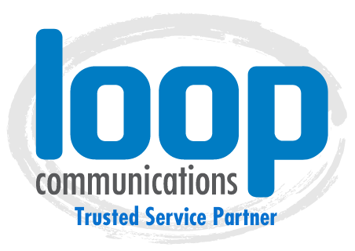
Interested in co-branding or additional marketing tools? Please contact marketing@loopcommunications.com, visit our Partner Resources Site or call 704-754-5605

Popular Hashtags
PRO TIP: use 15-25 hashtags in each post to gain more interest in your post
#VoIP #VoIPphone #VoIPphoneservice #VoIPservice #VoIPprovider #topVoIPproviders #whatisVoIP #VoIPnumber #businessVoIPproviders #msp #IT #loopcommunity #communication #pbx #pbxsystem #pbxphonesystem #VoIPpbx #whatispbx #business #telephone #telephonenumber #IP #voice #networksolutions #businessowner #businesssolutions
#businessphonesystems #voip #voipphonesystem #hostedphones #telecom #voice #yealink #cloudhosting #cloudpbx #loopcommunications #voippartner #hostedvoip #officephonesystem #businesssolutions #voipservice
Sample Social Media Posts
Right click on the images and save it to your computer files. Copy and paste the text or write your own! Don’t forget to represent your business name and contact information on every post.
We have partnered with Loop Communications to provide Business Text Messaging! SMS/MMS for business lets you send unlimited text messages including audio or visual files to your customers and employees from your local business phone number rather than your personal cell-phone number. Anyone can send text messages directly to your business phone and you will receive the message via email. Respond automatically from your email and the text will send back to the sender’s number, providing ultimate flexibility to always stay connected. Learn more here: https://bit.ly/3aqCB6s
(insert your business contact phone, email & website info here)

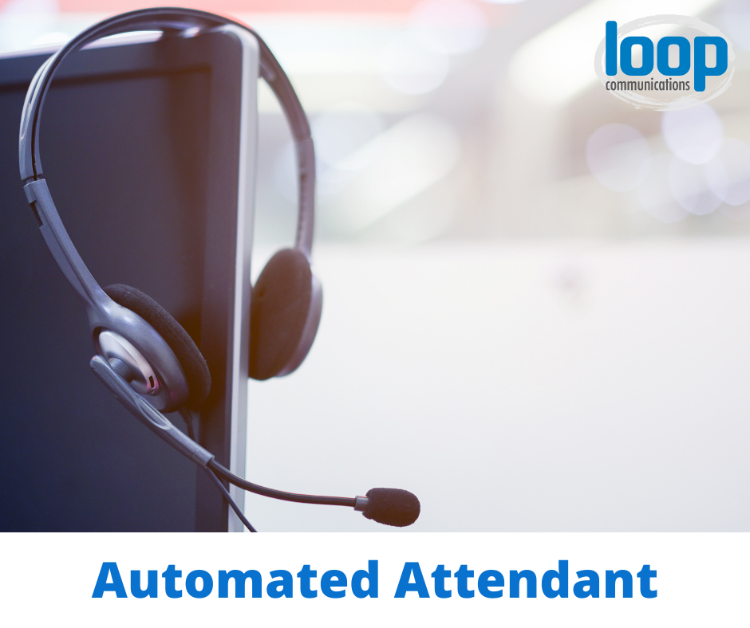
Included in your service agreement with our VoIP Partner, Loop Communications is an Automated Attendant: Voice Over Recording feature that plays a pre-recorded sample to help direct your customers when they call your business.
- You can call a number that we provide and record your own script and we will add it to your system.
- Send us a script telling us all the audio you’d like recorded – even things like “press zero to speak to an operator.” We’ll have a professional provide the voice over recording and include it as part of your service.
Check out sample recordings here: https://bit.ly/37hylnx

(insert your business contact phone, email & website info here)

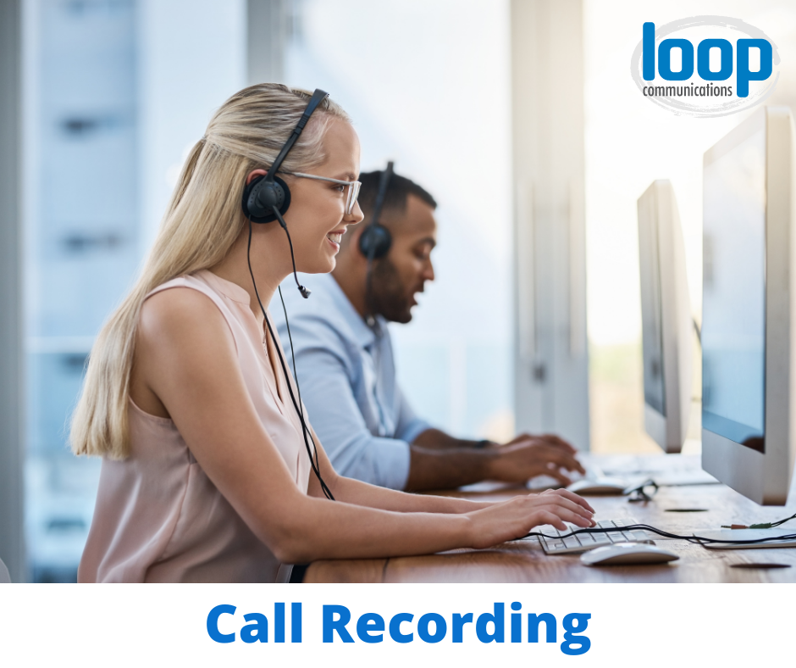
Improve the quality of your communications by utilizng our VoIP Service with Loop Communications. The Call Recording feature lets you record in detail any conversations had by the business and play it back later to see how you can handle customers better. Or, if you simply want to know the details of the call and weren’t able to take notes, now the info is readily available! Some will also use it for training their employees. Learn more here: https://bit.ly/2Zp5JV6

(insert your business contact phone, email & website info here)

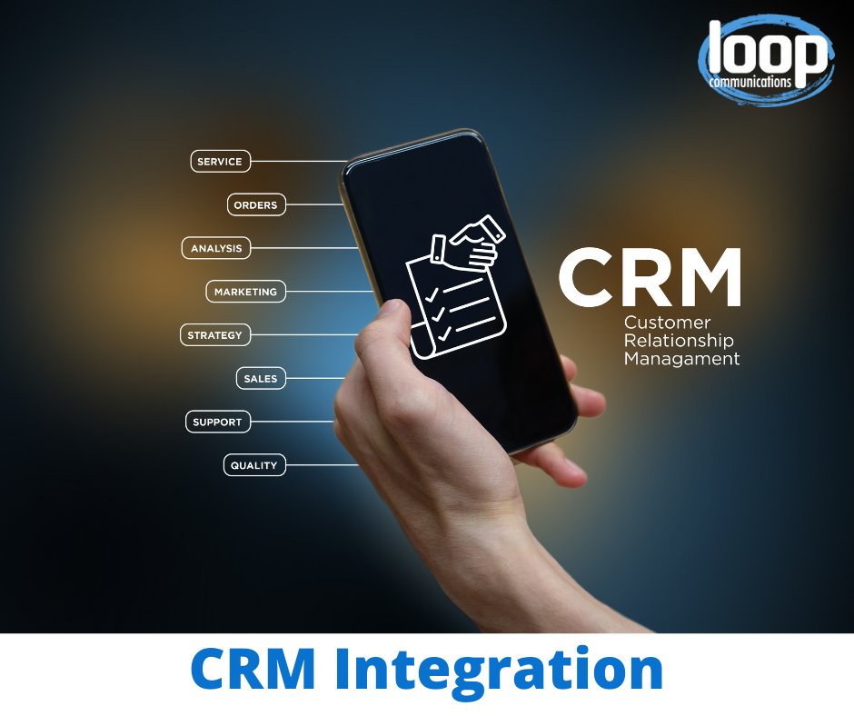
Our VoIP provider, Loop Communications integrates with CRM systems to help keep track of your customers and prospects. We can connect your phone system with your CRM account and exchange data between the two platforms-viewing customer info pop-ups, caller ID info, and click-to-dial extensions. Currently integrating with Salesforce, Connectwise, AMS 360, & QQ Catalyst. Learn more here: https://bit.ly/2ZmJCPh

(insert your business contact phone, email & website info here)

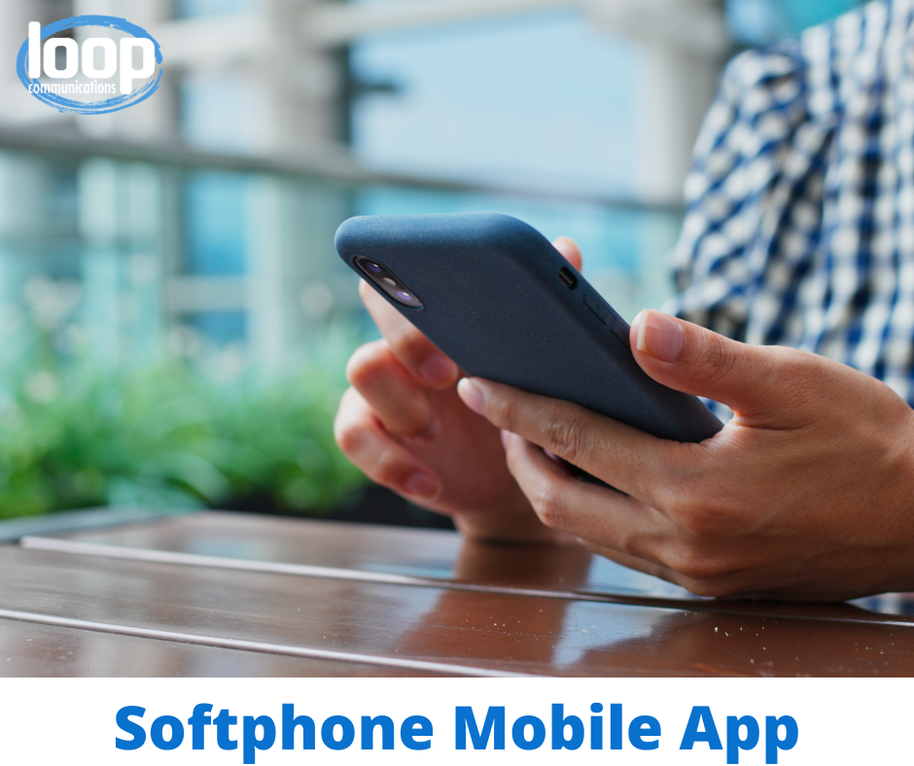
Access VoIP communication features through a single application that can be installed on your desktop, laptop computers or mobile devices. Our VoIP partner, Loop Communications allows customers to take advantage of remote work options while still staying connected to business.
Learn More Here: https://bit.ly/3rWhxdV

(insert your business contact phone, email & website info here)

Included in your service agreement with our VoIP provider, Loop Communications, is a Music on Hold option or Music on Transfer option to help keep your customers entertained if having to wait on the phone. They can use any royalty-free music or custom recordings—from soothing music to describing features of your company, Loop can accommodate a great option for you. Learn more here: https://bit.ly/3bemHuW

(insert your business contact phone, email & website info here)

Communicate easier when you are on the move! Loop Communications, our VoIP partner, provides you with a Voicemail to Email feature that sends audio (.wav) files directly to your email and includes a text transcription so you can either listen or read the voicemail message when you miss a call. Learn more here: https://bit.ly/2OBys72

(insert your business contact phone, email & website info here)

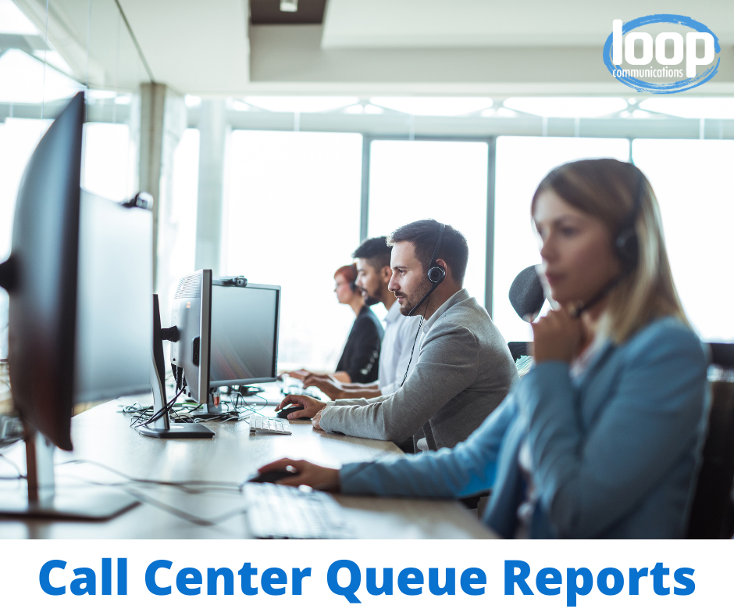
Help improve your call center efficiency and service with Call Center Queue Reports, provided by Loop Communications, our VoIP business phone provider. The reports can be sorted in multiple ways to give a better gauge on call activity. Some examples are displayed by queue, time, service level (length of call) and by agent. What is the average wait time? How many calls were abandoned last Tuesday? Find out more here: https://bit.ly/37iHPiI

(insert your business contact phone, email & website info here)

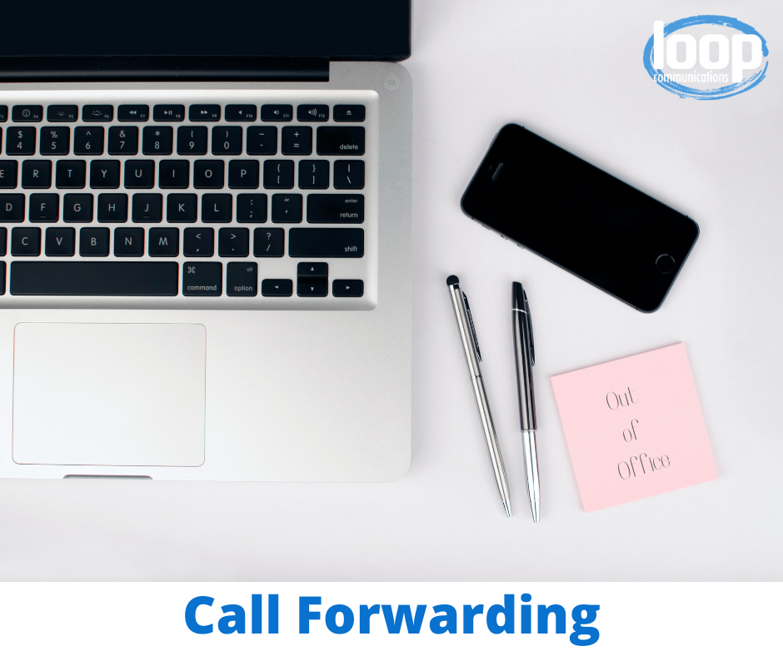
You’re not always in the office to get things done, so why be limited?! Take your business on the go with Call Forward, setup by our VoIP provider, Loop Communications. Each of your extensions can be altered through the user control panel to forward all calls to your mobile device. This feature is easy to enable or disable with the click of a button. Learn more here: https://bit.ly/2NybH3z

(insert your business contact phone, email & website info here)

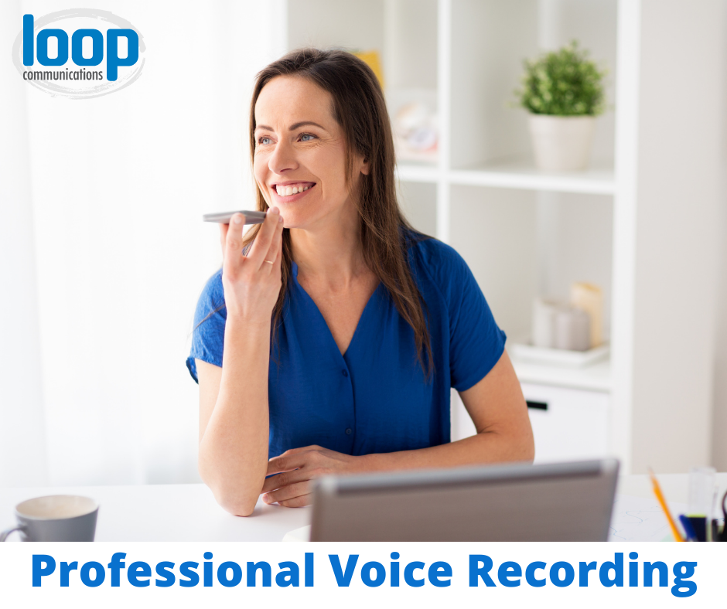
Included in your service agreement with our VoIP Partner, Loop Communications is an Automated Attendant: Voice Over Recording feature that plays a pre-recorded sample to help direct your customers when they call your business.
- You can call a number that we provide and record your own script and we will add it to your system.
- Send us a script telling us all the audio you would like recorded – even things like “press zero to speak to an operator.” We will have a professional provide the voice over recording and include it as part of your service.
Check out sample recordings here: https://bit.ly/37hylnx

(insert your business contact phone, email & website info here)

Additional Images

