Dear MSP Partners,
We appreciate your support as one of our trusted VoIP Managed Service Providers. To show our appreciation, we wanted to give you some useful tools to help market to new customers and share your available VoIP service offerings. Below is a guide to help you craft your own digital newsletter to send to your prospects. We have included images you can use to get started or feel free to use your own! Don’t forget to include [your business name] where necessary.

Also, be sure to take advantage of our Trusted Service Partner Badge that you can use in your social media posts, on your website and in your email signature to show your customers who you are proudly partnered with!
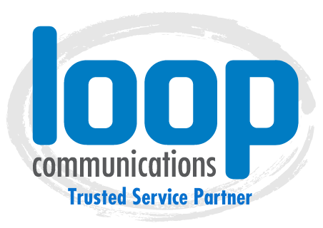
Need assistance, interested in co-branding or additional marketing tools? Please contact Sarah at marketing@loopcommunications.com, visit our Partner Resources Site or call 704-754-5605

Sample Email Newsletter Template

Right click on the images and save it to your computer files. Copy and paste the text or write your own! Don’t forget to represent your business name and contact information where necessary.

SAMPLE EMAIL #1
Dear xxx,
We are excited to announce that [your business name’s] has recently partnered with Loop Communications to provide our customers with Fully Managed Hosted VoIP and we are excited to share with you the many benefits included for your business.
Loop Communications offers a flexible, reliable, and most importantly, customer focused phone service. Take part in a cloud-based business phone system that is tailored to your needs rather than a cookie-cutter phone solution with constraining policies.
When you sign-up, your monthly service with Loop includes:
- Unlimited Calling—local and long distance within the United States, no surprises.
- No Maintenance—the phone system is fully hosted and managed by Loop, so there are no additional maintenance costs to worry about.
- Call Routing—you control call routing. Create inbound call plans to match your business needs.
- Location Flexibility—Direct Dial other locations or have one number route to multiple locations.
- Additionally, save 40-60% per month, avoid any long-term contracts, and receive the most passionate support!
Click here to learn more about Loop’s phone system or to see a full list of phone features, click here.
SAMPLE EMAIL #2

Dear xxx,
We are excited to announce that [your business name’s] has recently partnered with Loop Communications to provide our customers with Fully Managed Hosted VoIP and we are excited to share with you the many benefits included for your business.
Loop Communications offers a flexible, reliable, and most importantly, customer focused phone service. Take part in a cloud-based business phone system that is tailored to your needs rather than a cookie-cutter phone solution with constraining policies.
When you sign-up, your monthly service with Loop includes these Top Features & more:
Automated Attendant—This is your customers’ ticket to increase efficiency by eliminating the need for a live receptionist.
Call Forwarding— This very popular feature allows your customer’s calls to always be attended to and never ignored.
Call Parking— This feature works great if you need to move from place to place.
Call recording— This feature comes in handy when a conversation includes a lot of details that may need recording.
Caller ID— This feature provides important information on incoming calls before your team addresses the call.
SMS Texting to Email—This feature is also known as business text messaging and lets customers send unlimited texts from their local business phone numbers instead of a personal cell-phone number.
Softphone App—This allows customers to access communication features with efficiency through a single application that can be installed on the desktop, laptop computers, or mobile devices.
CRM Integration— This feature allows cloud VoIP providers, like Loop Communications to connect CRM accounts with your customer’s business phone systems and exchange data between the two platforms.
Voicemail to Email— We set up extensions at your customer’s office to have audio (.wav) files of voicemails sent immediately to the phone extension’s corresponding email addresses and the recipient can easily listen the message or respond.
Call Center Queue Reports—Help customers make it easier to understand and improve their call center efficiency.
Click here to learn more about Loop’s phone system or to see a full list of phone features, click here.

Additional Newsletter Images

